Integration of Keycloak with ADOPT

**Version History**

|  |  |  |  |
| --- | --- | --- | --- |
| **Versions** | **Developed by** | **Reviewer-01** | **Reviewer-02** |
| v01 | Komal Ghonge | Sumit Malhotra | Nilesh Rane |
|  |  |  |  |
|  |  |  |  |

Table of Contents

Change in the application.properties of source code. 1

Add Keycloak’s configuration in application.properties of Adopt_portal project. 1

Make configuration changes in Keycloak 2

Create realm 2

Create client 3

Create users. 4

Create roles. 4

Map users to roles. 5

# Change in the application.properties of source code.

## Add Keycloak’s configuration in application.properties of Adopt_portal project.

keycloak.auth-server-url=https://keycloakdev.statebanktimes.in:9100/auth/

keycloak.realm=Adopt

keycloak.resource=AdoptPortal

keycloak.public-client=true

keycloak.principal-attribute=preferred_username

Please find the screenshot below.

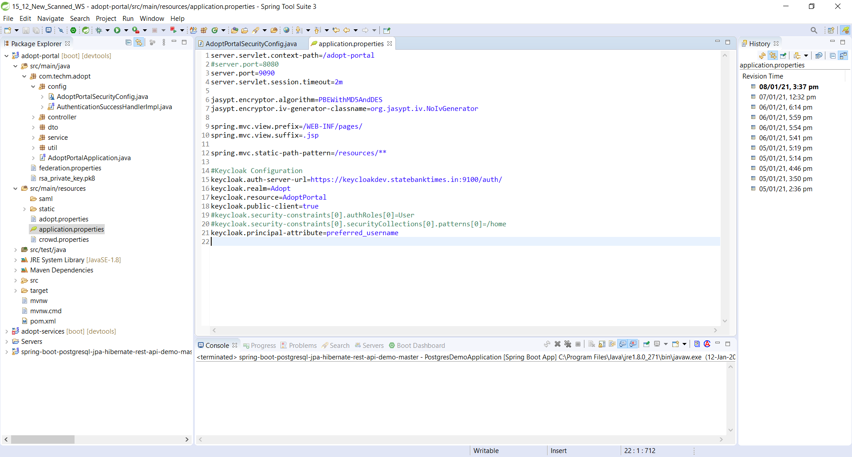

# Make configuration changes in Keycloak

## Create realm

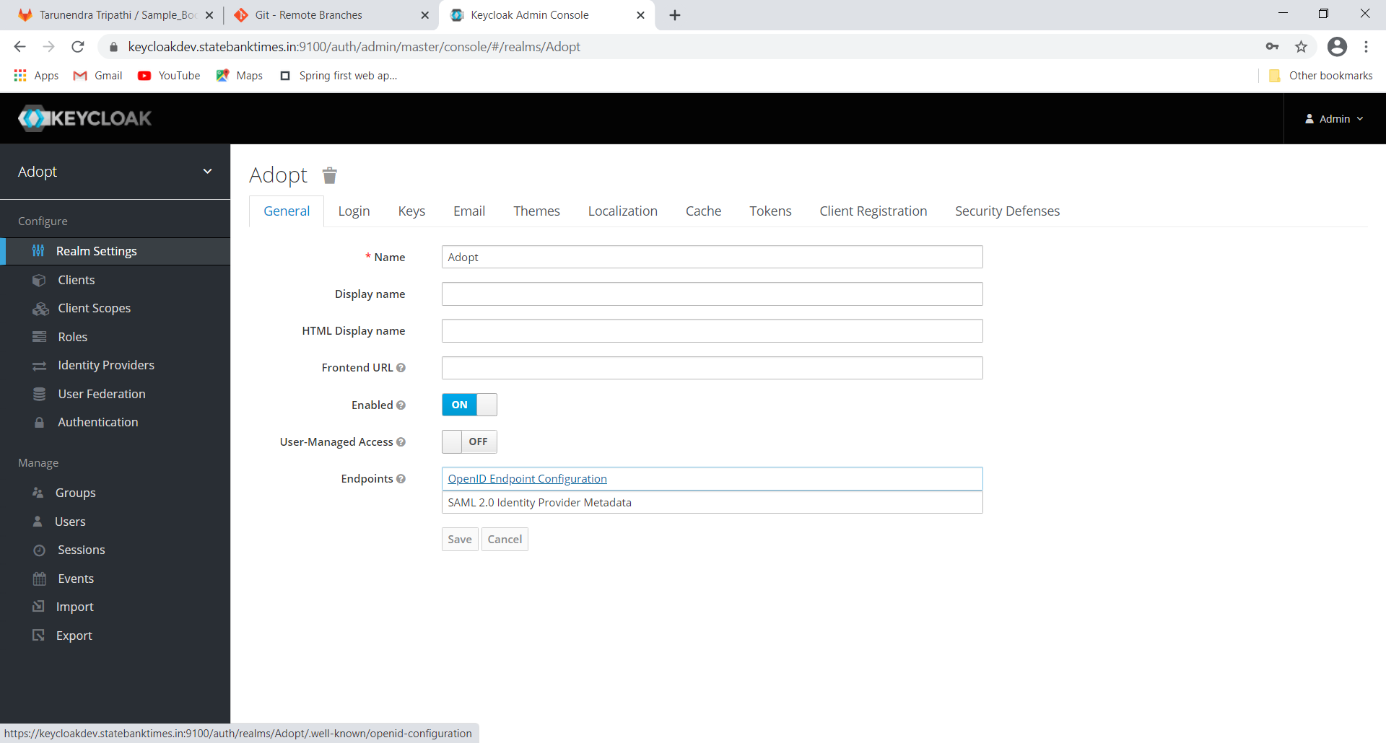

## Create client

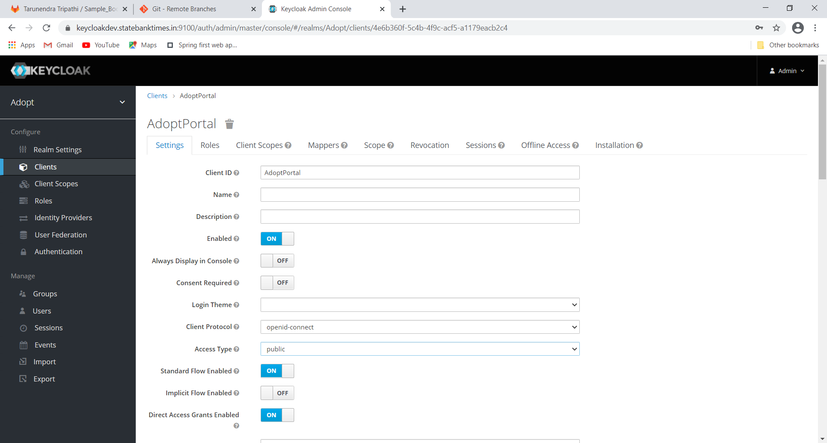

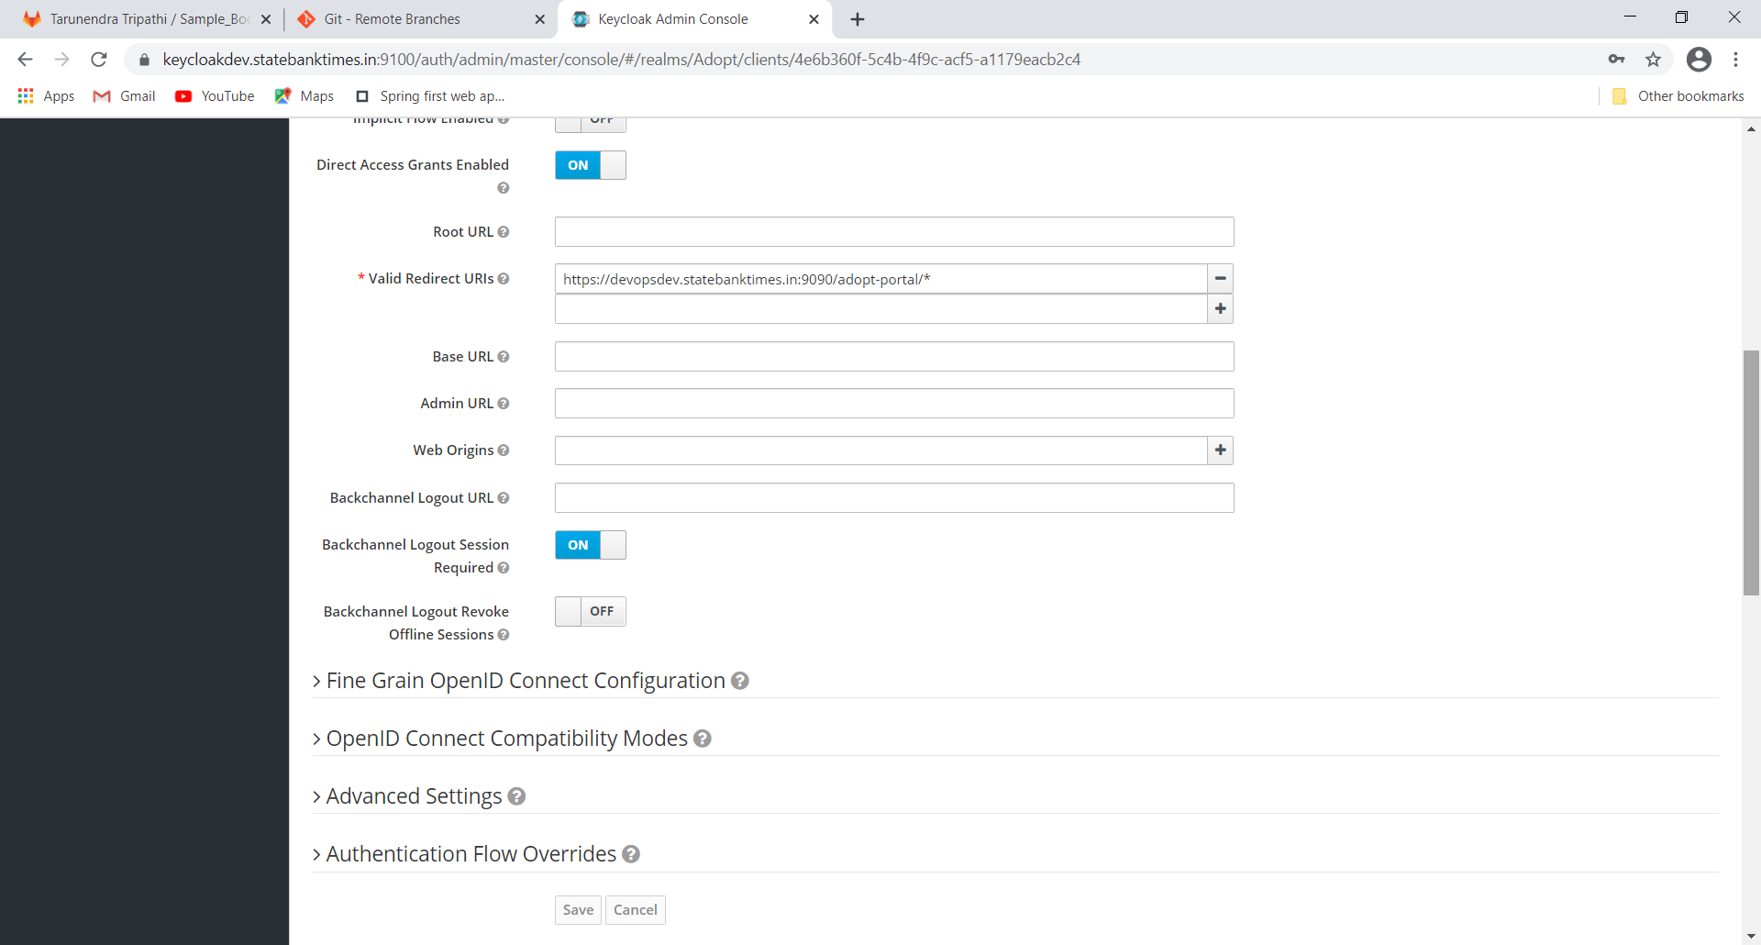

## Create users.

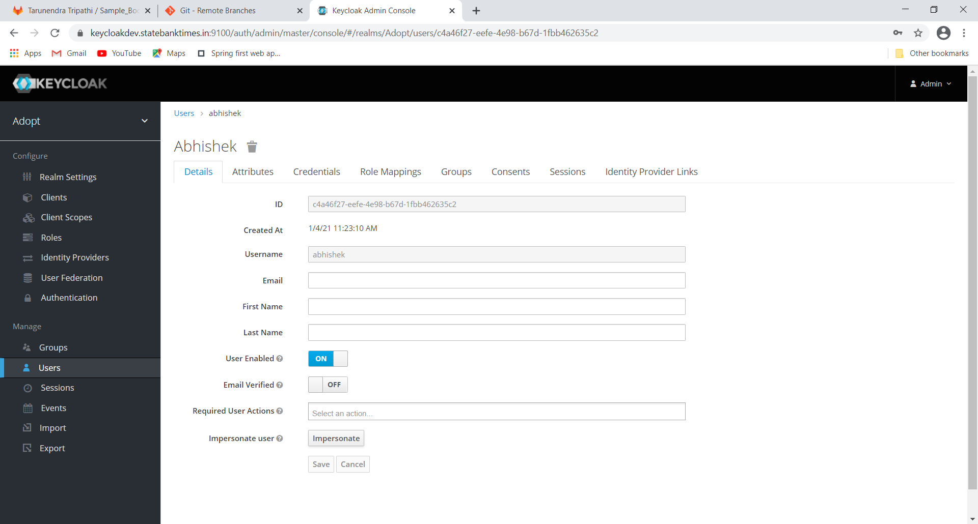

## Create roles.

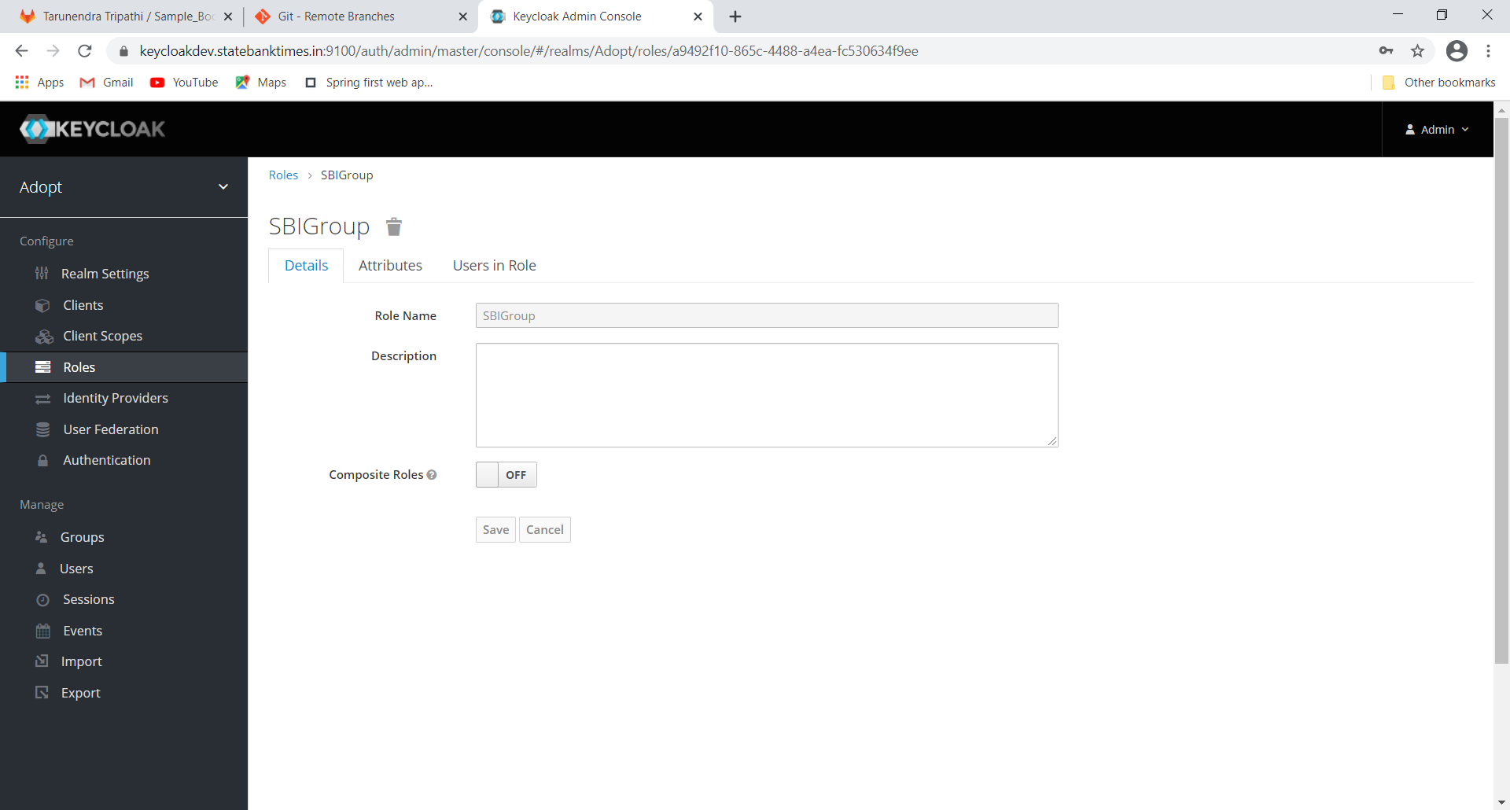

## Map users to roles.

